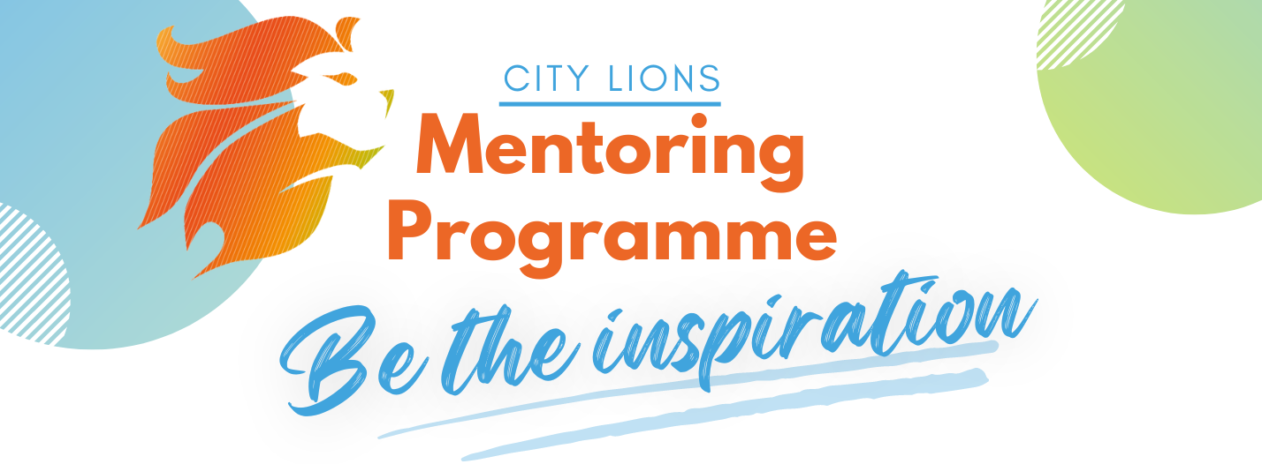
What is City Lion’s Mentoring?
You will get the opportunity to help shape a young person’s future. From January to June 2023, you will provide guidance and insight to a young person, developing their confidence, professional skills, and career choices. We aim to engage young peoples from disadvantaged backgrounds, those underrepresented in creative industries, and adversely affected by covid. City Lions mentoring programme ambition is to give a positive role model that opens their future opportunities. Are you that inspiration?
If so, sign up here!
“I really enjoyed this opportunity. The City Lions team were great, and I can strongly say I feel both myself and my mentee got some great learnings and development from the programme.”- 2022 Mentor
What is expected?
- Meet your mentee 1 or 2 times per month, at a time that suits you both, either in-person or virtually. (Total of 12 hours over 6 months)
- Mentoring will consist of ‘check-in’ and structured sessions working towards our key themes.
- Meeting mentees will be in Westminster or nearby area
What is provided?
- Support from City Lions throughout the programme
- Handbook to guide sessions
- Safeguarding training
- Enhanced DBS check
Benefits
- Opportunity to network with other mentors from the creative industries
- Develop your coaching and mentoring skills
- Gain an understanding of young people's unique perspectives
Timeline
- ‘Want to be a mentor?’ talk via Zoom on Friday 25 November at 5:30
- Deadline for applications on Monday 5 December
- Confirmation by Friday 9 December
- Interviews and DBS checks between Monday 12 to Wednesday 21 December
- Mentor training on Monday 9 January (TBC)
- Kick-off event at Lord Mayors parlour on Friday 13 January

